 | Year 12 Methods  Week 5 Quiz | $$\frac{}{16}$$

Name: __________________
1. | Find the derivative of $y=\sqrt{4x^{2}-3}.$  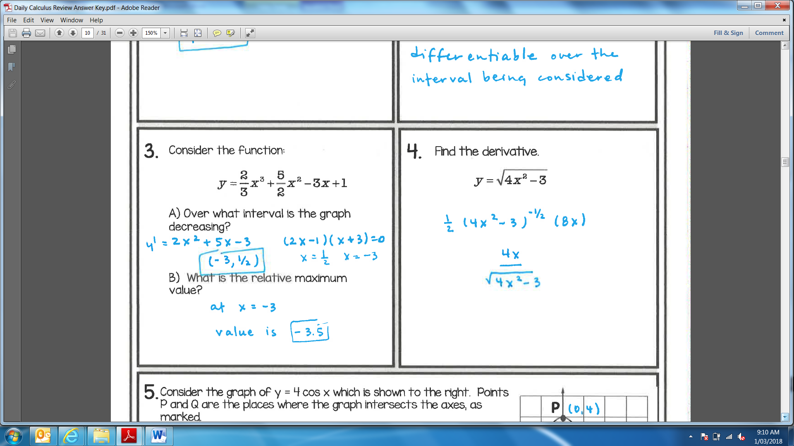 | 2
2. | Find the antiderivative:  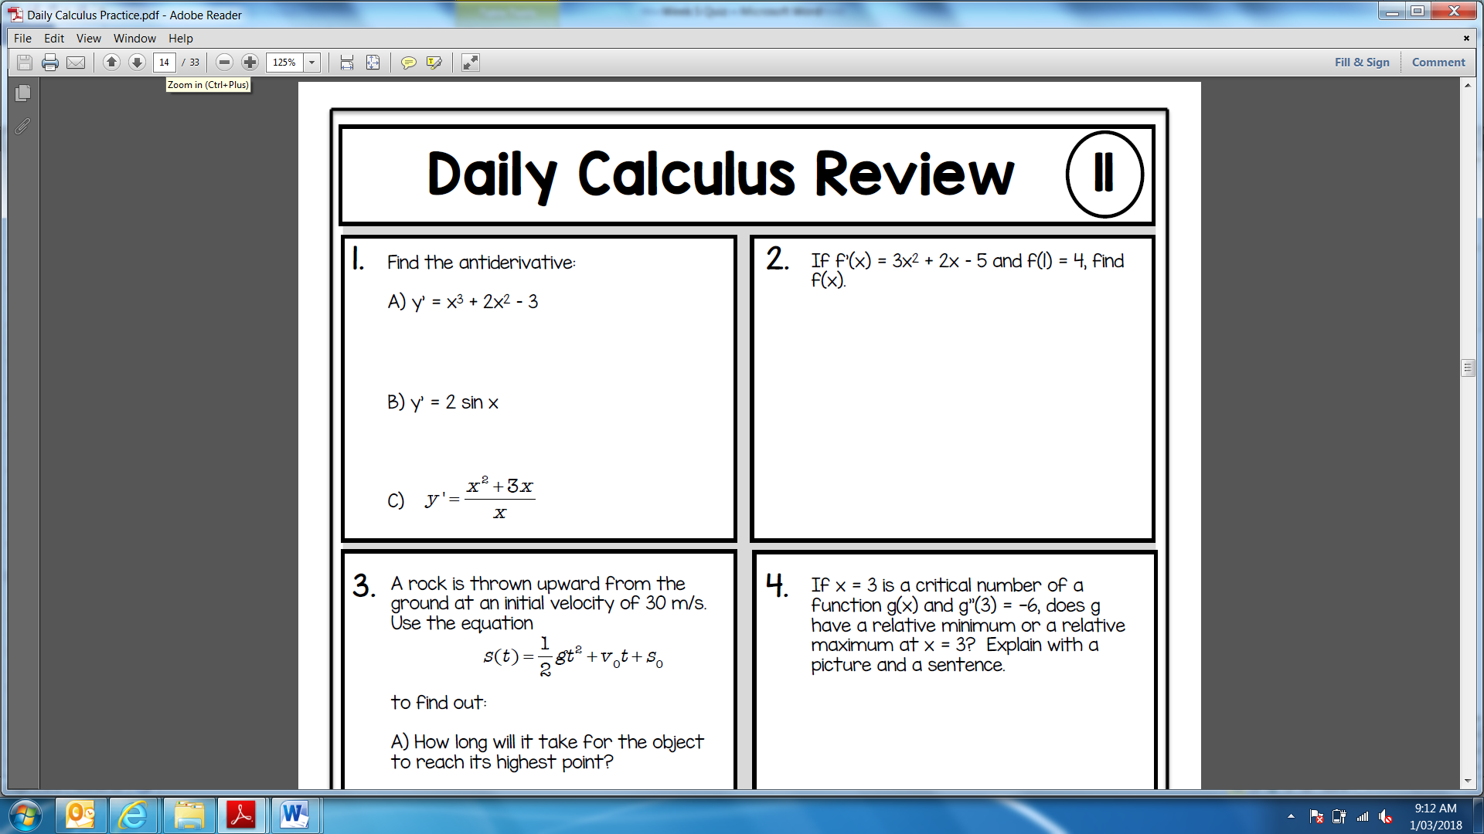  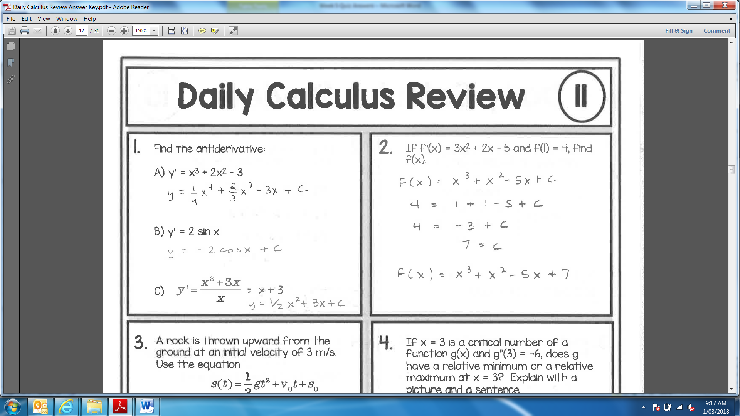 | 2
3. | Find the antiderivative:     | 1
4. | Consider the function $y=x^{2}+2.$ Use the right end-point method to find an approximation to the area between the curve and the x-axis over the interval [0,2]. Use 4 rectangles.  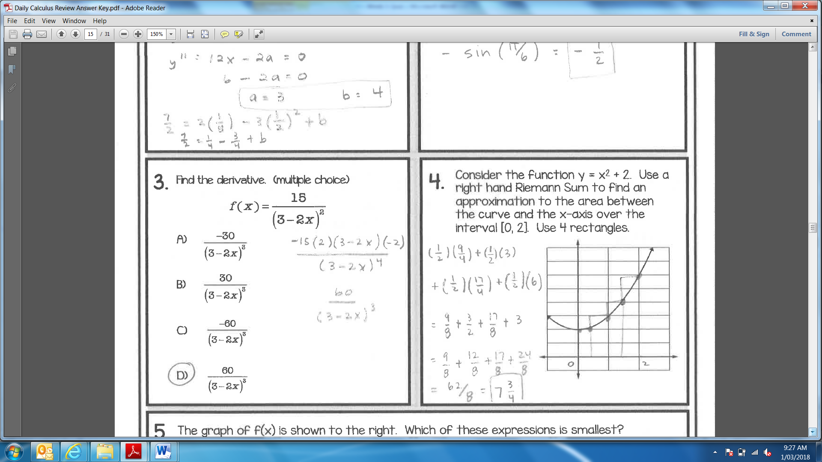 | 3
5. | Find:  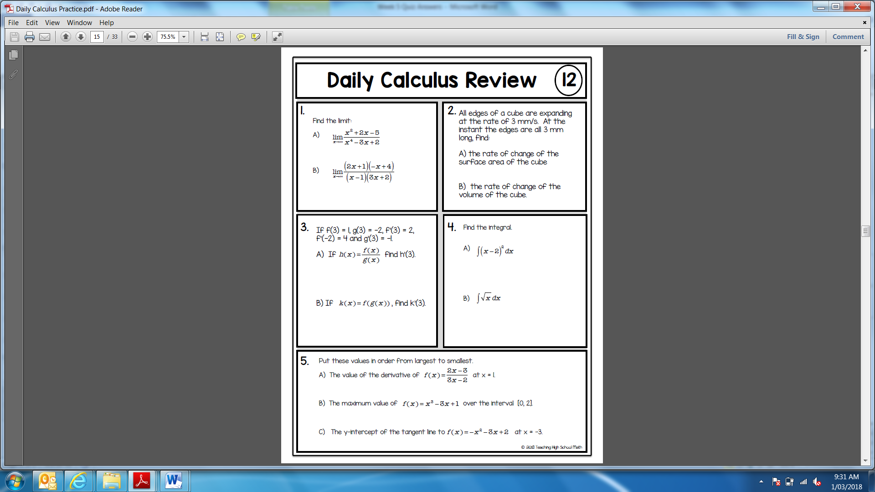  $$\int{(x-2)^{2}dx}= \frac{1}{1\left(2+1\right)}(x-2)^{2+1}= \frac{1}{3}(x-2)^{3}+c$$ | 2
6. | Find:    $$\int{\sqrt{x}dx}=\int{x^{\frac{1}{2}}dx}$$  $$= \frac{x^{\frac{3}{2}}}{\frac{3}{2}}+c$$  $=\frac{2}{3}x^{\frac{3}{2}}+c$ | 2
7. | Find:  $$\int{\frac{2}{(3x+1)}dx=2\int{\frac{1}{\left(3x+1\right)}dx}}$$  $$=2×\frac{1}{3}\ln\left|3x+1\right|+c$$  $=\frac{2}{3}\ln\left|3x+1\right|+c$ | 2
8. | Find:  $$\int{\frac{1}{(4x-1)}dx, x<\frac{1}{4}}$$  $$\int{\frac{1}{(4x-1)}dx=\frac{1}{4}\ln\left|-4x+1\right|+c}$$  $$=\frac{1}{4}\ln\left(1-4x\right)+c$$ | 2

